Дата: 22.03.2024 Клас: 7-Б

Предмет: Англійська мова

Тема: Різні види кінофільмів.

Мета: повторити та активізувати в мовленні учнів лексичний та граматичний матеріал теми, удосконалювати навички аудіювання, тренувати техніку читання,розвивати комунікативні здібності, практикувати учнів у письмі, заохочувати учнів піклуватися про своє здоровя та відмовлятися від шкідливих звичок, виховувати в учнів бажання вести здоровий спосіб життя.

Вчитель: Глуговська Л.Г.

**Хід уроку**

***1.Greeting***

Good afternoon, dear children! I’m glad to see you. Are you ready to start our lesson? Let’s start.

***2.Warming up***

Complete the sentences.

Доповніть речення (усно).

1. A movie that makes you scream is a ... .

2. A movie that is exciting with lots of guns and explosions is an ... movie.

3. Movies about the future or space are known as ... films.

4. A movie about real life is a ... .

5. An ... film has cartoon characters.

6. A film about lots of travelling and exciting or dangerous events is ... .

7. A film about love is ... .

8. A movie that makes you laugh is a ... .

***3. Listening***

*Watch the video about «Film genres. Жанри фільмів».*

*Перегляньте відео з теми.*

<https://www.youtube.com/watch?v=VAlEgtXt0B8>

1. ***Speaking***

***Оберіть правильний займенник:***

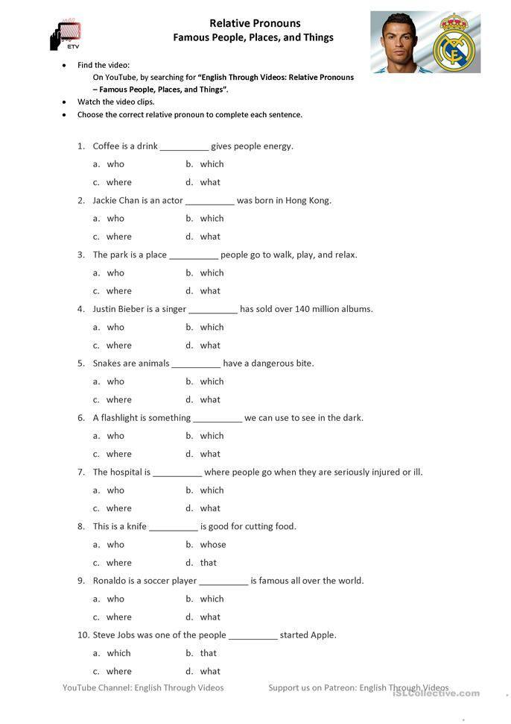

***5.* *Reading***

*Read the dialogue*

*Прочитайте діалог.*

Peter. Hey, Trish, how about going to the cinema tonight?

Trіsh. Sounds great! What would you like to see?

Peter. I don’t know... how about that new horror movie at the Panorama Cinema?

Trish. Oh, I heard about that. It sounds a little scary to me. I’m keen on romantic

movies. Or maybe a romantic comedy.

Peter. No way! I hate such boring things!

Trish. Really? Well then, what kinds of movies do you like?

Peter. I guess I’m crazy about action and adventure type of movies.

Trish. Well I guess they are okay, if they aren’t too bloody. I also heard about this

great new musical that just came out. What do you think about that?

Peter. Musical? I don’t know. That doesn’t sound too exciting. Is there anything we

can agree on?

Trish. It doesn’t seem like it. Oh, I remember another movie that came out last

week. It’s a mystery and it had a little romance and some action, too. I heard it’s pretty exciting because nobody can guess who the killer is and it has a surprise ending. What do you think about that one?

Peter. I guess that doesn’t sound too bad. What time does it start?

***6. Homework***

Домашнє завдання:

1. Опрацювати конспект, повторити вивчені слова.